Evidence-Based Goal Setting, Habit Design and Compassionate Recovery

Executive summary
The strongest evidence does not support treating goal setting as a one-size-fits-all SMART exercise. The older goal-setting literature consistently shows that specific, challenging goals improve performance when the task is familiar, performance is controllable, feedback is available, and the person is committed. But on new, complex, or skill-building tasks, learning or mastery goals usually outperform pure outcome or performance goals, because they direct attention toward strategy discovery rather than immediate scorekeeping. More recent critiques of SMART in health and physical activity argue that the acronym is often used as a simplistic mnemonic rather than a theory-based method, and that it ignores the crucial question of what kind of goal is being set in the first place. [1]
Implementation intentions, or if–then plans, are among the most robust tools for translating intention into behaviour. The classic meta-analysis found a medium-to-large effect on goal attainment of about d = 0.65 across 94 tests, and a much larger 2024 meta-analysis covering 642 independent tests found benefits across behavioural, cognitive, and affective outcomes, with effect sizes ranging roughly from d = 0.27 to d = 0.66. The newer review also found that plans work better when they use a true contingent if–then format, when underlying motivation is already high, and when the plan is mentally rehearsed at least once. Mechanistically, these plans do not seem to work mainly by boosting self-efficacy or desire; rather, they increase cue accessibility and strengthen cue–response links. [2]
Habit formation is slower and more variable than popular culture suggests. The famous “21-day” claim is not a scientific law. In Phillippa Lally’s real-world longitudinal study, the median time to reach 95% of asymptotic automaticity was 66 days, with a range of 18 to 254 days among participants whose data fit the expected curve well; a newer 2024 systematic review found reported medians around 59–66 days, reported means around 106–154 days, and overall ranges from 4 to 335 days across studies. Context stability, consistent repetition, enjoyment or intrinsic reward, and preparatory routines all help; complexity, unstable contexts, and overly ambitious targets slow things down. Missing one opportunity does not appear to destroy a forming habit, but repeated lapses and shame-based interpretations raise risk. [3]

Goal structures that hold up under evidence
A rigorous goal system should start with a hard distinction that many apps and coaching systems blur: goal structure is not just formatting. George Doran’s original SMART article used Specific, Measurable, Assignable, Realistic, and Time-related as a managerial aid, and even Doran wrote that not every objective would need every criterion. Later versions quietly changed the letters, especially A and R, and the modern use of SMART often treats the acronym as if it were scientific law. Contemporary reviews in physical activity have argued that SMART is widely disseminated but not well grounded in theory, inconsistently defined, and liable to distract people from more important choices like whether the goal is a behaviour goal, an outcome goal, a learning goal, or a stretch goal. [4]
By contrast, goal-setting theory gives more useful guidance. Locke and Latham’s work shows that specific, difficult goals tend to improve performance more than vague “do your best” goals when the task is known and controllable. But goal-setting theory also explicitly distinguishes performance goals from learning goals, and later work shows that on complex or novel tasks, learning goals usually work better because they improve strategy search and self-efficacy. Winters and Latham’s experiment is still one of the clearest demonstrations: on a simple task, an outcome goal outperformed “do your best”; on a complex task, a learning goal outperformed both an outcome goal and “do your best.” Stretch goals occupy a different category again: they may promote exploration and ambition, but they are risky and are often most attractive to organisations that can least absorb the downside. [5]

Comparison of evidence-based goal structures
Goal structure | What it is | Where it tends to work best | Main failure mode
SMART as a mnemonic | A formatting aid for writing goals clearly | Administrative clarity, documentation, straightforward tasks | Treated as theory when it is not; ignores goal type and challenge level
Specific difficult performance goal | A precise target standard to hit | Familiar, controllable tasks with feedback and sufficient skill/resources | Can narrow attention, increase pressure, and backfire on novel tasks
Learning or mastery goal | A goal to acquire strategy, knowledge, or skill | Complex, changing, or early-stage tasks | Too vague if it lacks behavioural anchors and review criteria
Outcome goal | A desired end state such as weight, grade, revenue, finish time | Long-range direction and motivation | Often weakly controllable day to day
Process or behaviour goal | A target action under direct control | Daily execution, habit building, recovery after setbacks | Can feel disconnected from “why” if outcome is never revisited
Stretch goal | A deliberately extreme target | Innovation settings with slack, strong feedback, and tolerance for experimentation | Risky escalation, tunnel vision, corner-cutting, or demoralisation
Evidence note: This synthesis draws on Doran’s original article, the critique of SMART in physical activity, goal-setting theory, learning-versus-performance goal research, and the stretch-goals literature. [6]
A practical rule follows from the evidence: pair goals vertically. Use an outcome goal for direction, a process goal for control, and a learning goal when the method is not yet mastered. In behaviour-change taxonomy, goal setting (outcome) and goal setting (behaviour) are explicitly separate techniques, which is a useful design clue: the person who wants lower blood pressure should still track the behaviour that could plausibly cause it, such as minutes walked, medication adherence, or sodium logging. [7]

Specific, attainable target examples across domains
The examples below are illustrative targets, not universal prescriptions. They are designed to operationalise controllability, challenge, and reviewability, and the health examples are aligned with WHO adult physical activity guidance where relevant. [8]
Domain | Outcome goal | Process goal | Numeric target and timeframe
Health | Improve cardiometabolic fitness | Brisk walking plus strength work | 150 minutes/week of moderate activity for 8 weeks, plus 2 strength sessions/week; review every Sunday
Health | Increase vegetable intake | Build a dinner-plate routine | Fill half the dinner plate with vegetables on 5 nights/week for 6 weeks
Productivity | Advance a priority work project | Front-load deep work before reactive work | Complete one 50-minute priority block before email on 4 weekdays/week for 6 weeks
Productivity | Reduce deadline stress | Create earlier completion buffer | Finish the first draft of each key deliverable 48 hours before deadline for the next 6 deliverables
Learning | Improve exam retention | Use spaced retrieval rather than rereading | Do 3 retrieval-practice sessions of 20 minutes/week plus 1 cumulative quiz/week for 8 weeks
Learning | Build a new professional skill | Practise methodically and log errors | Complete 2 deliberate-practice sessions of 30 minutes/week and record 1 improvement note after each session for 10 weeks
These examples are defensible because they convert vague intentions into measurable, proximal actions. The health activity example maps directly to WHO recommendations for adults; the learning example maps to the well-supported literatures on retrieval practice and spacing; and the productivity examples follow the broader evidence that specific, behaviour-level goals are easier to execute and review than broad aspirational outcomes. [9]

Goal quality checklist
Criterion | Why it matters | Pass question
Meaningful | Goals aligned with personal values and autonomous reasons are pursued more persistently | Does the person know why this matters beyond “I should”?
Correct goal type | Task demands differ; learning goals suit complexity better than pure outcome goals | Is this outcome, process, learning, performance, or stretch, and is that choice deliberate?
Controllable | Daily behaviour is more actionable than distal outcomes | Can the person directly do the target behaviour today?
Challenging but credible | Too easy under-motivates; too hard destabilises | Does the goal feel effortful yet plausible?
Specific enough | Ambiguity impairs execution | Would two people read this goal the same way?
Time-bounded | Open-ended aspirations drift | Is there a review date and a decision date?
Cue-linked | Execution improves when linked to a stable cue | Is there a clear “when/where/after what/when feeling what” trigger?
Reviewable | Monitoring improves attainment | Is there a metric that can be logged weekly?
Recoverable | Lapses are normal; shame escalates attrition | Is there a fallback version and a restart rule?
Evidence note: This checklist is an evidence-informed synthesis of goal-setting theory, the learning-vs-performance literature, behaviour-change taxonomy, implementation-intention research, self-monitoring meta-analysis, and relapse-prevention work. [10]

Implementation intentions and cue design
Implementation intentions are one of the most practical upgrades available once a goal exists. Their core form is simple: If situation X occurs, then I will perform response Y. The classic meta-analysis reported d = 0.65 for goal attainment across 94 independent tests. The larger 2024 meta-analysis extended that result across 642 tests, finding reliable benefits for cognitive, affective, and behavioural outcomes, with stronger effects when the plan used a bona fide if–then contingency, when the person was already motivated, and when the plan was rehearsed. A meta-analysis of 66 tests further found that the benefits of implementation intentions are not mainly explained by stronger intentions or higher self-efficacy; the more plausible mechanism is enhanced detection of the cue and stronger cue–response association. [2]
That mechanism matters because it tells you how to write a good plan. The best plans are contingent, specific, singular, and behavioural. They name one cue, one first response, and preferably one immediate, observable action. “If it is 7:00 am, then I will put on my shoes and walk for ten minutes” is stronger than “If I have time, then I’ll try to exercise.” Recent meta-analytic and taxonomy work also shows that effective cues can be time-and-place, task junctures, or internal states such as a thought, feeling, or urge. In the behaviour-change taxonomy, action planning explicitly includes environmental, social, and internal contexts, and prompts/cues are defined as environmental or social stimuli that occur around the time or place of performance. [11]

If–then template with examples
Situation to plan for | Template | Strong example
Starting a wanted behaviour | If [time/place/event], then I will [first observable action] | If it is 7:30 am and I have finished brushing my teeth, then I will put on my walking shoes and go outside for 10 minutes
Protecting focus | If [distraction cue], then I will [protective action] | If I open my laptop for work, then I will start my 50-minute priority block before checking inboxes
Learning routine | If [study cue], then I will [retrieval action] | If it is 8:00 pm on Monday, Wednesday, and Saturday, then I will do 20 minutes of flashcard recall before any rereading
Coping with an internal trigger | If I feel [urge/emotion/thought], then I will [coping response] | If I feel the urge to skip the workout because I’m tired, then I will do the 5-minute starter version and reassess after that
Recovering from a lapse | If I miss the planned session, then I will [restart move] | If I miss today’s walk, then I will restart tomorrow with the 10-minute version, not try to “make up” the missed time
A good if–then plan usually meets five standards. The cue is easy to notice; the response is the first action, not an abstract ambition; the plan addresses the actual friction point rather than a generic one; the wording is brief enough to remember; and the person mentally rehearses it at least once. If motivation is uncertain, the evidence supports upgrading the method to mental contrasting with implementation intentions—often known as WOOP or MCII—which adds an explicit obstacle-identification step. Meta-analytic evidence suggests MCII improves goal attainment with a small-to-moderate effect, around g = 0.34. [12]
Cue design deserves separate attention because implementation intentions are only as good as the cues they use. Habit and planning research converges on three cue families. Contextual cues are features of place, objects, people, and sequences in the environment; temporal cues are times of day, days of week, or recurring intervals; emotional or internal cues are feelings, urges, or recurrent thoughts. In real-world habit data, physical location and time of day matter strongly, and recent longitudinal work shows that context stability predicts greater automaticity and higher goal attainment. Emotional cues can be powerful for coping plans, but because internal states fluctuate, they tend to work best when the planned response is very small and concrete. [13]
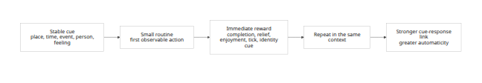
This cue–routine–reward loop is not just folk wisdom. Health-behaviour reviews identify repetition, associated context cues, and rewards as the central ingredients of habit formation, while newer papers show that intrinsic reward value and context stability independently predict stronger habits. Reward helps not only because it feels good, but because it supports repetition and strengthens the learning of the cue–response link. [14]

Habit formation timelines and the 21-day myth
The cleanest way to understand habit formation is to stop asking, “How many days does it take?” and instead ask, “What does the distribution look like?” In Lally and colleagues’ real-world daily-diary study, automaticity increased along an asymptotic curve rather than a straight line. Among participants whose data fit that curve well, the median time to reach 95% of asymptotic automaticity was 66 days, with a range of 18 to 254 days. Early repetitions produced larger gains than later repetitions, and a single missed opportunity did not materially disrupt the process. [15]
The broader evidence makes the variability even clearer. A 2024 systematic review and meta-analysis covering 20 studies and 2,601 participants found that the four studies directly reporting timing yielded medians around 59–66 days, means around 106–154 days, and ranges from 4 to 335 days. The review concluded that health habits commonly need about two to five months to become automatic for many people, with major individual variation. That is the most honest headline: habit formation is gradual, highly variable, and behaviour-dependent. [16]
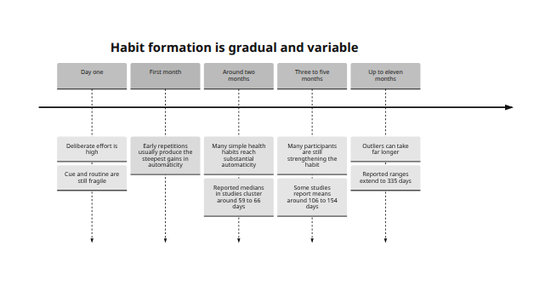
The “21-day” belief is therefore best understood as a myth created by simplification, not by primary evidence. The 2024 review explicitly states that available evidence refutes the idea that habits form in about 21 days, and traces that popular notion to Maxwell Maltz’s Psycho-Cybernetics, which was not a habit-formation experiment. [17]
What speeds habit formation up? The evidence points to consistent performance, stable context, self-selection, enjoyment or intrinsic reward, and preparatory habits such as laying out exercise clothes or building an evening setup routine. Morning practice sometimes shows an advantage over evening practice, and habits practised in more stable contexts produce greater automaticity and better goal attainment. What slows it down? Unstable contexts, complex behaviours, and goals that demand too much effort too soon. Studies on nutrition habit formation and context-stability interventions both suggest that context stability is one of the strongest predictors of habit strength, often rivalling or exceeding raw repetition alone. [18]
One implication is easy to miss: “simple” is strategic. Behaviour-change taxonomy includes graded tasks, meaning initially easy tasks that become harder only after success. That is exactly what a rational habit-formation system should do. The aim is not to prove seriousness by choosing a heroic first dose; it is to make repetition likely enough, and cueing stable enough, that automaticity can accumulate. [19]

Review loops and compassionate recovery
Progress monitoring is one of the better-supported self-regulation tools in the literature. Harkin and colleagues’ meta-analysis found that monitoring goal progress promotes goal attainment, with larger effects when progress is physically recorded or reported publicly, and the authors concluded that interventions that increase the frequency of monitoring are likely to improve behaviour change. In physical activity specifically, meta-analytic evidence also shows that self-monitoring combined with additional support components produces a modest but sustained increase in step count. [20]
The literature does not identify one universal review cadence that is optimal for every goal. So the most defensible practice is an evidence-informed cadence stack rather than a single magic frequency. Daily or near-daily logging is best for behaviour execution. Weekly reviews are best for pattern detection and troubleshooting. Monthly reviews are best for goal redesign, dose changes, and deciding whether the goal type itself is wrong. That recommendation is an inference from self-monitoring evidence, control-theory models of feedback loops, and habit-formation research—not a cut-off directly validated in one trial. [21]

Review loop rules
- Track behaviours more often than outcomes. Log the action you control, such as sessions completed, minutes walked, retrieval quizzes done, or focus blocks started. Outcome metrics matter, but less frequently. [22]
- Use both retrospective and prospective review. Retrospective review asks what happened, what helped, and what blocked progress. Prospective review converts the main blocker into a new if–then plan for the next period. [23]
- If behaviour frequency is low, redesign the cue before increasing effort. Weak cueing is often the problem earlier than weak motivation. [24]
- If adherence is decent but outcomes lag, adjust dose or method, not necessarily the goal itself. A process can be faithfully executed yet underpowered. [25]
- Use a smaller version after disruption. After illness, travel, caregiving strain, or sleep loss, switch temporarily to a maintenance version rather than abandoning the goal. [26]
- Do not treat a lapse as evidence about identity. Treat it as evidence about context, dose, cue quality, or friction. [27]
Handling missed goals without shame is not just a kindness issue; it is a persistence issue. A meta-analysis of 94 peer-reviewed articles found that self-compassion is positively associated with both physical health and health-promoting behaviour, with the behaviour association around r = 0.26. Research on self-compassion and failure also shows that self-compassion is linked with more adaptive coping and learning-oriented responses, while self-criticism amplifies negative affect after setbacks. In a teeth-flossing experiment, responding to failure with self-compassion improved mood relative to self-criticism. [28]
Relapse-prevention research adds a hard warning here. Marlatt’s model describes the abstinence violation effect, in which guilt, shame, and self-blame after a lapse increase the likelihood of a larger relapse. The recommended response is not indulgence, but compassionate, analytical debriefing: identify the high-risk situation, notice the coping skills that were absent, and plan the next response. This logic transfers well beyond addiction treatment. For everyday goals, the central point is the same: lapse is information; moralising it makes it worse. [29]
A practical recovery protocol should therefore combine reframing with graded action. The reframe is: “I missed the behaviour; that does not mean I am the kind of person who fails.” The graded action is: “What is the smallest next repetition that preserves the loop?” That pairing is highly consistent with self-compassion research, graded-task behaviour change, and relapse-management principles. [30]
Recovery script
I missed the plan. That is a data point, not a verdict.
What cue failed, what friction showed up, and what is the smallest next action I can do at the next available cue?
I restart with the minimum viable version, and I update the plan if the old one was unrealistic.
This script is a synthesis rather than a verbatim protocol, but it operationalises the direction of the evidence: reduce shame, preserve self-regulation, and learn from the lapse rather than turning it into identity collapse. [31]

Goals and missions module design
What follows is an evidence-informed product design synthesis, not a directly trialled app specification. It translates the literature on goal type, implementation intentions, habit formation, self-monitoring, and compassionate lapse management into a plausible “Goals & Missions” module for digital coaching. [32]
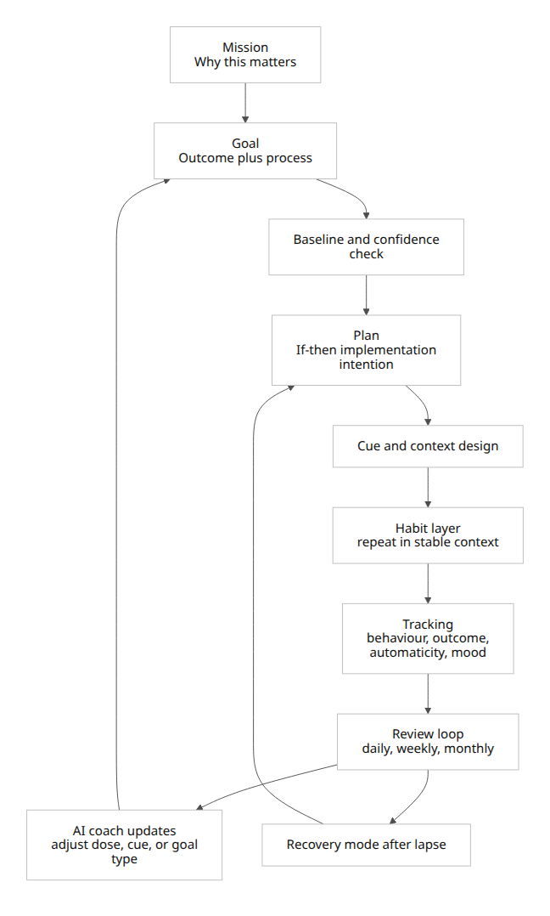

Architecture, UX elements, core data fields and workflows
Layer | UX element | Core data fields | Why it belongs
Mission | Short “why this matters” card | mission title, values tag, personal reason | Autonomous meaning supports persistence and reduces hollow compliance
Goal | Goal composer with type selector | goal type, outcome metric, behaviour metric, target, timeframe | Goal type matters; outcome and behaviour goals should be distinguished
Baseline | Baseline capture and feasibility prompt | baseline level, resources, barriers, confidence note | Challenge should be credible, not fantasy
Plan | If–then builder | cue type, cue text, response text, fallback version, rehearsal complete | Implementation intentions improve translation of intention into action
Habit | Cue designer and routine stacker | place, time, preceding event, people present, internal cue, reward | Stable contexts and immediate rewards support automaticity
Tracking | Friction-light logging | behaviour count, duration, completion yes/no, automaticity rating, enjoyment, missed-cue reason | Monitoring behaviours and context produces better review quality
Review | Weekly and monthly review templates | adherence, outcome trend, blocker category, next experiment | Frequent monitoring and feedback improve attainment
Recovery | Lapse screen with compassionate prompt | lapse date, trigger, interpretation, restart version, new if–then plan | Shame escalates relapse risk; debriefing reduces it
Privacy | Data control centre | consent, retention period, deletion option, export option, local-processing preference | Data minimisation and transparent governance are core trust requirements
A strong module should also avoid several common UX mistakes. It should not default everyone into the same SMART form. It should not treat streaks as the primary motivational system for high-friction lifegoals, because streak loss can magnify shame-based dropout. It should not force outcome-only goals when the user clearly needs a behaviour or mastery goal. And it should not bury cue design, because cue quality is often the difference between a plan and a fantasy. These design choices follow directly from the limitations of acronym-led goal setting, the power of if–then planning, and the importance of stable context. [33]

Evidence-based workflow
A clean workflow starts with mission, then goal type selection, then baseline, then if–then planning, then cue selection, then tracking, then review, and finally adjustment or recovery. For a brand-new or complex goal, the product should default to a mastery/process framing and only later ask for more ambitious performance targets. For a simple or already-practised behaviour, the product can support a more specific hard target immediately. That sequencing reflects the evidence that learning goals outperform performance goals during early complexity, while specific and challenging performance goals are more effective once strategy is known. [34]

AI update rules for automated coaching
The thresholds below are pragmatic coaching heuristics, not cut-offs established in a single definitive trial. They are designed to be consistent with the evidence on self-monitoring, context stability, habit formation, self-compassion, and responsible AI governance. [35]
- Suggest creating an if–then plan when a goal has a metric but no cue, or when the user has had at least 3 opportunities and adherence is below about 80% in the first week. The issue is probably translation into action, not desire. [36]
- Suggest shrinking the goal when behaviour completion falls below about 60% over 14 days, or after 2 consecutive misses on a daily habit. Offer a graded-task version instead of an all-or-nothing message. [37]
- Suggest cue redesign when missed attempts are repeatedly tagged as “forgot,” “wrong time,” or “context changed,” or when the same behaviour is attempted in highly variable contexts. [24]
- Do not recommend harder stretch targets during context instability such as illness, travel, caregiving spikes, or major schedule disruption. Switch to maintenance mode instead. [38]
- Recommend increasing difficulty only after stable success, for example after roughly 3 weeks of high adherence and lower perceived effort. This uses habit consolidation rather than early overreach as the trigger for ambition. [39]
- When a lapse occurs, always use non-shaming language and prompt a short debrief: what cue failed, what obstacle arose, what smaller restart version should be used? [27]
- Track only what is necessary. Collect the minimum data needed for coaching, separate sensitive health data from generic productivity data, allow deletion and export, and periodically purge raw detail that is no longer needed. [40]
- Explain coaching logic. Show the user why an adjustment was suggested, provide the metric or pattern that triggered it, and make it easy to override. Trustworthy AI guidance emphasises transparency, accountability, and human-centred design. [41]
- Use privacy-enhancing defaults. Prefer onboard or local processing where feasible, short retention windows for sensitive logs, and explicit opt-ins for mood, health, or location data. WHO and NIST both frame trust, human rights, and risk management as central rather than optional. [42]

Open questions and limits
The evidence base is stronger for health behaviour, exercise, study behaviour, and general laboratory self-regulation than for broad workplace productivity systems. That means some productivity recommendations above are principled extrapolations from goal theory and behaviour-change research rather than direct app-trial results. [43]
The evidence on time to automaticity is still based on a surprisingly small number of studies that directly estimate duration, which is why any precise universal timeline should be treated sceptically. Likewise, the specific coaching thresholds proposed for AI suggestions are design heuristics, not canonical clinical thresholds. [44]
Even so, the core conclusions are high confidence: choose the right goal type, convert it into cue-linked behaviour, expect habit formation to take longer than 21 days, monitor progress regularly, and treat missed goals as process feedback rather than moral failure. [45]

[1] [5] [10] [32] [43] [45] https://med.stanford.edu/content/dam/sm/s-spire/documents/PD.locke-and-latham-retrospective_Paper.pdf
https://med.stanford.edu/content/dam/sm/s-spire/documents/PD.locke-and-latham-retrospective_Paper.pdf
[2] [23] [36] https://kops.uni-konstanz.de/entities/publication/2e749bfb-8533-437c-8203-7e788c910c5f
https://kops.uni-konstanz.de/entities/publication/2e749bfb-8533-437c-8203-7e788c910c5f
[3] [15] [39] https://repositorio.ispa.pt/bitstream/10400.12/3364/1/IJSP_998-1009.pdf
https://repositorio.ispa.pt/bitstream/10400.12/3364/1/IJSP_998-1009.pdf
[4] [6] https://www.eval.fr/wp-content/uploads/2020/01/S.M.A.R.T-Way-Management-Review-eval.fr_.pdf
https://www.eval.fr/wp-content/uploads/2020/01/S.M.A.R.T-Way-Management-Review-eval.fr_.pdf
[7] https://www.sciencedirect.com/topics/psychology/behavior-change-technique
https://www.sciencedirect.com/topics/psychology/behavior-change-technique
[8] [9] https://www.who.int/initiatives/behealthy/physical-activity
https://www.who.int/initiatives/behealthy/physical-activity
[11] [12] https://www.researchgate.net/publication/378870694_The_When_and_How_of_Planning_Meta-Analysis_of_the_Scope_and_Components_of_Implementation_Intentions_in_642_Tests
https://www.researchgate.net/publication/378870694_The_When_and_How_of_Planning_Meta-Analysis_of_the_Scope_and_Components_of_Implementation_Intentions_in_642_Tests
[13] [24] [26] https://pmc.ncbi.nlm.nih.gov/articles/PMC9226889/
https://pmc.ncbi.nlm.nih.gov/articles/PMC9226889/
[14] https://dornsife.usc.edu/wendy-wood/wp-content/uploads/sites/183/2023/10/Wood.Neal_.2016.pdf
https://dornsife.usc.edu/wendy-wood/wp-content/uploads/sites/183/2023/10/Wood.Neal_.2016.pdf
[16] [17] [18] [44] https://www.mdpi.com/2227-9032/12/23/2488
https://www.mdpi.com/2227-9032/12/23/2488
[19] [22] [37] https://digitalwellbeing.org/wp-content/uploads/2016/11/BCTTv1_PDF_version.pdf
https://digitalwellbeing.org/wp-content/uploads/2016/11/BCTTv1_PDF_version.pdf
[20] [21] [25] [35] https://pubmed.ncbi.nlm.nih.gov/26479070/
https://pubmed.ncbi.nlm.nih.gov/26479070/
[27] [30] [31] https://self-compassion.org/wp-content/uploads/2020/10/PhillipsHine2019.pdf
https://self-compassion.org/wp-content/uploads/2020/10/PhillipsHine2019.pdf
[28] https://pubmed.ncbi.nlm.nih.gov/31842689/
https://pubmed.ncbi.nlm.nih.gov/31842689/
[29] https://pmc.ncbi.nlm.nih.gov/articles/PMC6760427/
https://pmc.ncbi.nlm.nih.gov/articles/PMC6760427/
[33] https://researchportal.scu.edu.au/view/pdfCoverPage?download=true&filePid=1397623990002368&instCode=61SCU_INST
https://researchportal.scu.edu.au/view/pdfCoverPage?download=true&filePid=1397623990002368&instCode=61SCU_INST
[34] https://journals.sagepub.com/doi/10.1177/1059601196212007
https://journals.sagepub.com/doi/10.1177/1059601196212007
[38] https://papers.ssrn.com/sol3/papers.cfm?abstract_id=1698304
https://papers.ssrn.com/sol3/papers.cfm?abstract_id=1698304
[40] https://ico.org.uk/for-organisations/uk-gdpr-guidance-and-resources/data-protection-principles/a-guide-to-the-data-protection-principles/data-minimisation/
https://ico.org.uk/for-organisations/uk-gdpr-guidance-and-resources/data-protection-principles/a-guide-to-the-data-protection-principles/data-minimisation/
[41] [42] https://www.who.int/publications/i/item/9789240029200
https://www.who.int/publications/i/item/9789240029200

